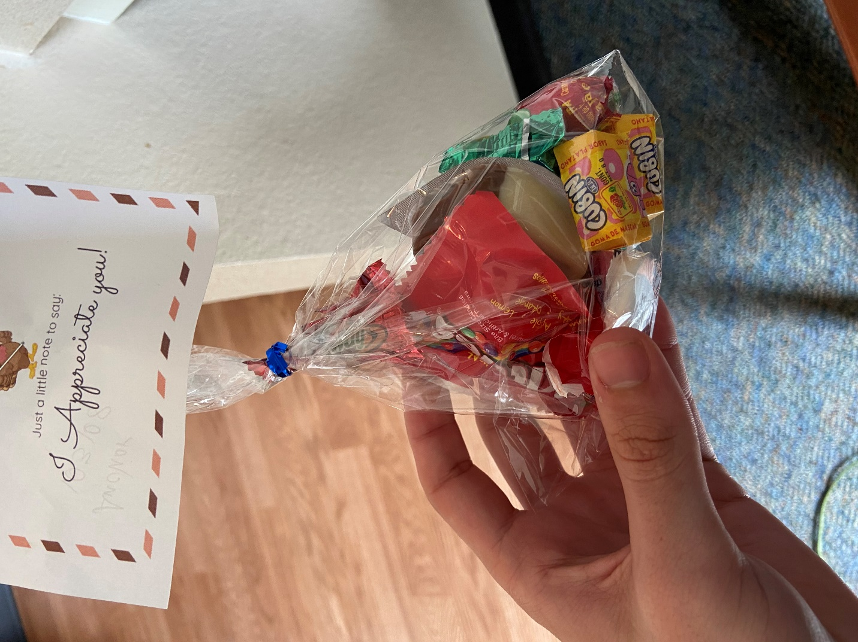

There was an I engage so you could send someone a special bag full of stuff that you got to “Make” online and they would give to you on a random day. This was fun and cute. I liked being able to do something for free. Money has been hard because of finding a job and covid so being able to do something small was nice.